GHG Emissions Report
City of Sammamish
DeCember 2025

Prepared by cascadia consulting group

Contents
Introduction 1
Background 1
Methodology 1
Inventory Findings & Trends 2
Communitywide GHG Emissions 2
Built Environment 6
Transportation 7
Solid Waste 8
Refrigerants 8
Key Terms 9
Appendix A: K4C GHG Inventory Methodology A-1
Transportation A-3
Built Environment A-4
Solid Waste A-5
Refrigerants A-5
Influence of Local Conditions A-6
Appendix B: Retroactive Methodology Updates B-1
Appendix C: K4C Comparison Tables C-1

Introduction

Background
As part of the King County – Cities Climate Collaboration (K4C), the city of Sammamish has committed to reducing greenhouse gas (GHG) emissions within its community and building resilience to climate change effects. The following report provides a summary of current communitywide greenhouse gas emissions for Sammamish in 2022 and 2023 and compares these totals to 2019. Greenhouse gas analyses allow jurisdictions to better understand their greenhouse gas emissions trends over time and prioritize engagement with community and implementation activities on the largest sources of emissions. This summary is intended to provide insight into the sources of the city of Sammamish’s greenhouse gas emissions, highlighting key areas where emission reductions are needed.

Methodology
Sammamish’s GHG emissions inventory was performed using guidance from the U.S. Community Protocol for Accounting and Reporting of GHG Emissions (USCP).0F This protocol is the industry standard for quantifying emissions produced by the activities of Sammamish’s residents, businesses, and visitors. Sammamish’s communitywide emissions were quantified for the 2022 and 2023 calendar years and compared to 2019 GHG emissions calculated through the Puget Sound Regional Emissions Analysis.
Emission sources included in the K4C GHG inventories include energy, transportation, solid waste, and refrigerant emissions. These sectors are aligned with recommended protocols and industry best practices. This inventory represents emissions occurring as a result of the activities of the city of Sammamish’s residents, employees, and visitors. This inventory is not intended to represent the City’s municipal operations carbon footprint.

Inventory Findings & Trends

Communitywide GHG Emissions
In 2022 and 2023, the city of Sammamish’s community produced an estimated 478,725 and 499,678 metric tons of CO₂ emissions (MTCO₂e), respectively. The community’s largest sources of emissions as of the 2023 communitywide GHG inventory came from the built environment and transportation & other mobile sources sectors. The largest emission sources included natural gas (27%), aviation (25%), and electricity (20%). Since 2019, overall communitywide emissions in Sammamish have decreased by 9%. A detailed summary of emissions can be found in Figure 1 and Table 1.
In addition, Table 2 reports “core” emissions sources, emissions produced by sectors commonly included in community greenhouse gas inventories. Core emission sources are sources which city governments typically have the most influence over (e.g., through local policy mechanisms such as local codes/regulations). Core emissions in this inventory include electricity (residential and commercial), natural gas (residential and commercial), on-road vehicles, and solid waste generation and disposal. A detailed summary of core emissions can be found in Figure 3 and Table 2.

Figure 1. Total communitywide GHG emissions profile (MTCO₂e).
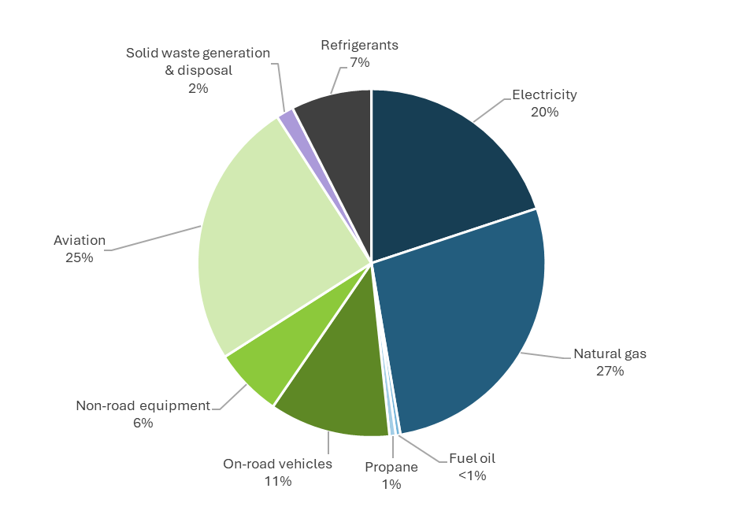
Table 1. Total communitywide GHG emissions, by sector (MTCO₂e).
GHG Emissions Sector | 2019 Emissions (MTCO₂e) | 2022 Emissions (MTCO₂e) | 2023 Emissions (MTCO₂e) | 2023 % of Total Emissions | 2019 to 2023 % Change | 2023  Per-Capita (MTCO₂e)
Built Environment | 272,547 | 259,292 | 241,551 | 48% | -11% | 3.5
Electricity | 147,235 | 116,030 | 99,497 | 20% | -32% | 1.5
Natural Gas | 121,488 | 138,487 | 137,002 | 27% | +13% | 2.0
Propane | 2,147 | 2,651 | 2,899 | <1% | +35% | <1
Fuel Oil | 1,677 | 2,124 | 2,154 | <1% | +28% | <1
Industrial Processes | N/A | N/A | N/A | 0% | N/A | 0
Transportation | 239,132 | 173,719 | 212,625 | 43% | -11% | 3.1
On-Road Vehicles | 67,563 | 51,396 | 56,118 | 11% | -17% | <1
Non-Road Equipment | 29,395 | 31,586 | 31,876 | 6% | +8% | <1
Aviation | 142,173 | 90,736 | 124,631 | 25% | -12% | 1.8
Solid Waste | 6,135 | 8,333 | 8,050 | 2% | +31% | <1
Landfill | 4,926 | 6,835 | 6,405 | 1% | +30% | <1
Compost | 1,209 | 1,497 | 1,646 | <1% | +36% | <1
Refrigerants | 34,262 | 37,380 | 37,452 | 7% | +9% | <1
Refrigerants | 34,262 | 37,380 | 37,452 | 7% | +9% | <1
Total Emissions | 552,075 | 478,725 | 499,678 | 100% | -9% | 7.3
Core Emissions | 342,408 | 314,237 | 300,658 | 60% | -12% | 4.4
Figure 2. Total communitywide GHG emissions, by sector and source (MTCO₂e).
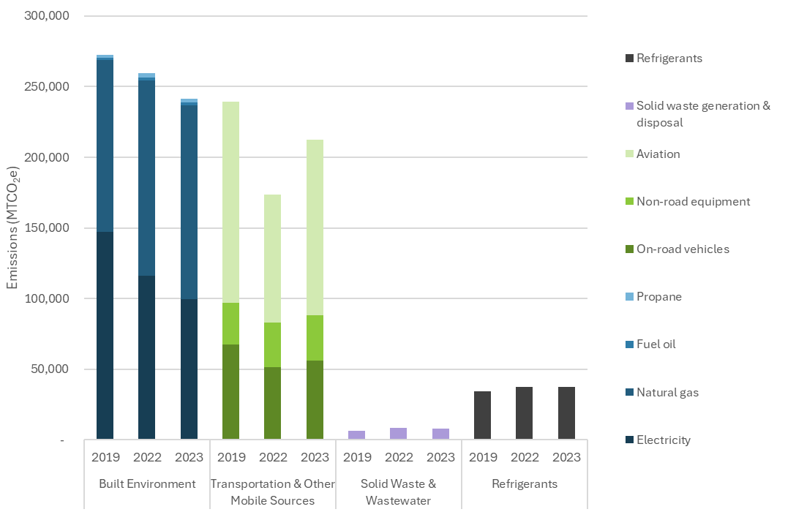

Figure 3. Core communitywide GHG emissions profile (MTCO₂e).
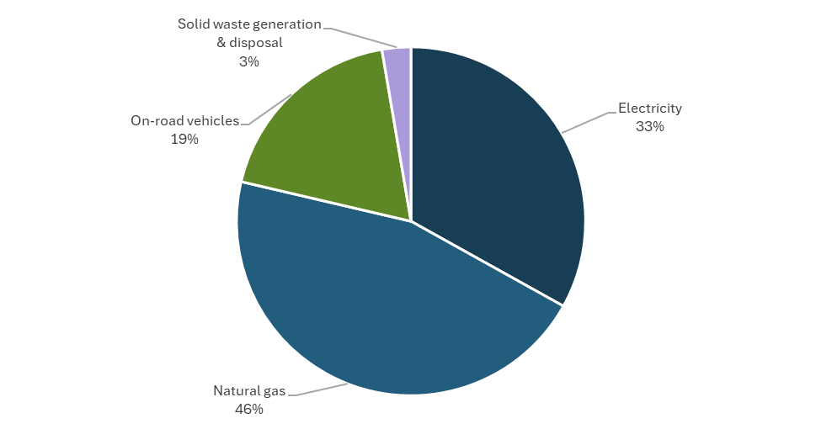
Table 2. Core communitywide GHG emissions, by sector (MTCO₂e).
GHG Emissions Sector | 2019 Core Emissions (MTCO₂e) | 2022 Core Emissions (MTCO₂e) | 2023 Core Emissions (MTCO₂e) | 2023 % of Core Emissions | 2019 to 2023 % Change | 2023  Core Per-Capita (MTCO₂e)
Built Environment | 268,709 | 254,507 | 236,489 | 79% | -12% | 3.5
Electricity | 147,223 | 116,022 | 99,489 | 33% | -32% | 1.5
Natural Gas | 121,486 | 138,485 | 137,000 | 46% | +13% | 2.0
Transportation | 67,563 | 51,396 | 56,118 | 19% | -17% | <1
On-Road Vehicles | 67,563 | 51,396 | 56,118 | 19% | -17% | <1
Solid Waste | 6,135 | 8,333 | 8,050 | 3% | +31% | <1
Landfill | 4,926 | 6,835 | 6,405 | 2% | +30% | <1
Compost | 1,209 | 1,497 | 1,646 | <1% | +36% | <1
Total Core Emissions | 342,408 | 314,237 | 300,658 | 100% | -12% | 4.4

Built Environment
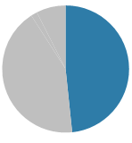
The built environment sector includes emissions from the consumption of electricity, natural gas, and other fuel sources (fuel oil and propane) within residential, commercial, and industrial buildings. The built environment sector made up 48% of Sammamish’s 2023 communitywide emissions. A detailed overview of emissions from these sources is provided below.

Summary
- Since 2019, Sammamish’s built environment emissions have decreased by 11%. The largest change to built environment emissions came from the industrial sector, in which emissions decreased by 36%.
- Emissions from electricity consumption accounted for 20% of Sammamish total communitywide GHG emissions in 2023, which has decreased by 32% since 2019.
- Natural gas accounted for 137,002 MTCO₂e in 2023, making up 27% of Sammamish total communitywide GHG emissions, which increased by 13% since 2019.
- Fuel oil and propane emissions in 2023 made up <1% and <1% of 2023 emissions, which increased by 28% and increased by 35% since 2019, respectively.
Figure 4. Total energy emissions trends by year.
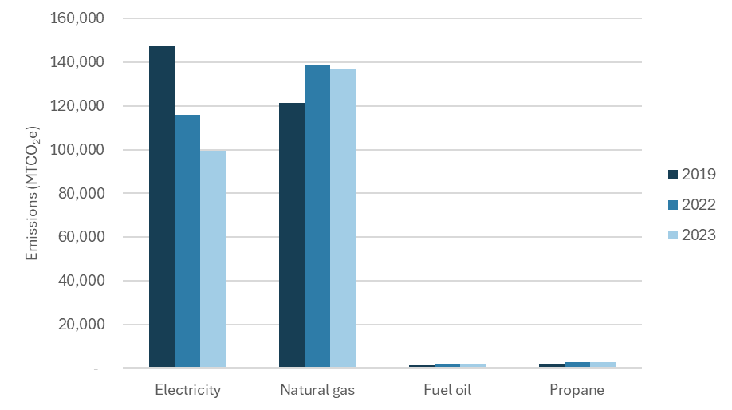

Transportation
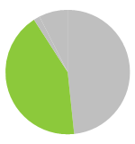
The transportation sector includes emissions from communitywide transportation mobile sources including on-road vehicles, non-road equipment, and aviation. The transportation sector made up 43% of Sammamish’s 2023 communitywide emissions. A detailed overview of emissions from these sources is provided below.

Summary
- Since 2019, transportation emissions have decreased by 11%.
- On-road vehicles – which include passenger vehicles, freight, and service vehicles (heavy, medium, and light vehicles) - represent 11% of Sammamish’s 2023 communitywide GHG emissions, which decreased by 17% since 2019.
- Non-road equipment—which includes recreational, construction, industrial, lawn/garden, agriculture, commercial, logging, airport support, oil field, pleasure craft, and railroad related equipment—made up 6% of Sammamish 2023 communitywide GHG emissions, which increased by 8% since 2019.
- Aviation emissions come from fuel burned to power aircrafts. Attributing aviation emissions to a particular city can be challenging because emissions are often burned outside of the geographic boundary of the city. Using a passenger-based approach, this inventory uses all of the aviation fuel sold from Seattle-Tacoma International Airport (SEA) that can be attributed to Sammamish residents or visitors based on airport passenger surveys and downscaled by household and income estimates. Aviation emissions accounted for 25% of Sammamish’s 2023 communitywide GHG emissions, which decreased by 12% since 2019.
Figure 5. Total transportation GHG emissions by year.
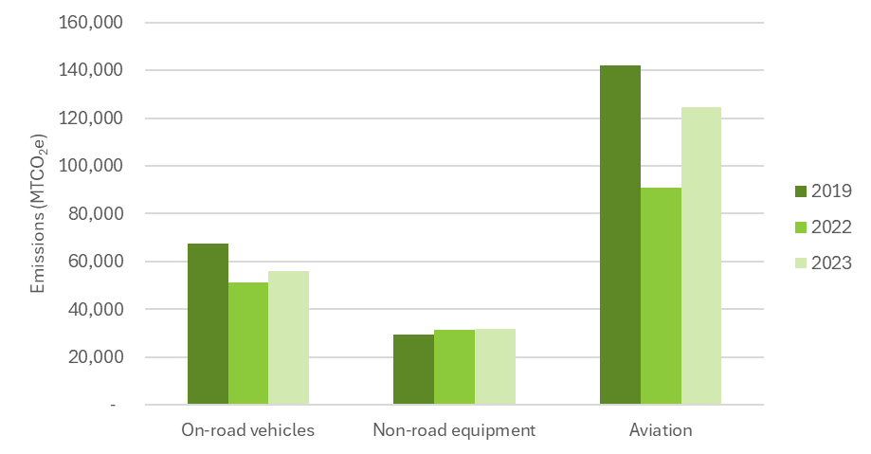

Solid Waste
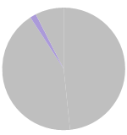
Emissions from the solid waste sector include emissions produced from the generation, transportation, and disposal of landfilled and composted waste produced within Sammamish. The solid waste sector made up 2% of Sammamish’s 2023 communitywide emissions. A detailed overview of emissions from these sources is provided below.

Summary
- In 2023, solid waste accounted for 2% of communitywide emissions, which increased by 31% since 2019.
- Emissions from landfill accounted for 1% of those emissions, while emissions from compost made up <1%, which increased by 30% and increased by 36% since 2019.

Refrigerants
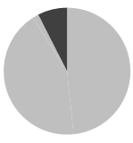
Greenhouse gas emissions can also stem from leaks from contained sources, such as from refrigeration and industrial equipment. This inventory estimated emissions from leakage of potent greenhouse gases from refrigerants used in buildings and vehicles.

Summary
- Refrigerants emissions made up an estimated 7% of 2023 communitywide emissions in Sammamish—from leakage of hydrofluorocarbons (HFCs) and HFC substitutes used for cooling and refrigeration, which increased by 9% since 2019.

Key Terms
Table 3. Glossary of key terms in GHG analysis.
Term | Description
Activity data | Data on the magnitude of human activity resulting in emissions taking place during a given period of time. Data on energy use, fuel use, miles traveled, input material flow and product output are all examples of activity data that might be used to compute GHG emissions.
CO₂ equivalent (CO₂e) | The universal unit for comparing emissions of different GHGs expressed in terms of the global warming potential of one unit of carbon dioxide.
Emission factor | A unique value for determining an amount of a GHG emitted on a per unit activity basis (for example, metric tons of CO₂ emitted per million Btus of coal combusted, or metric tons of CO₂ emitted per kWh of electricity consumed).
Fugitive emissions | Emissions that are not physically controlled but result from the intentional or unintentional release of GHGs. They commonly arise from the production, processing, transmission, storage and use of fuels or other substances, often through joints, seals, packing, gaskets, etc. Examples include hydrofluorocarbons from refrigeration leaks, SF6 from electrical power distributors and CH₄ from solid waste landfills.
Greenhouse gases (GHGs) | Defined in the Local Government Operations Protocol as GHGs are the six gases identified in the Kyoto Protocol: carbon dioxide (CO₂), nitrous oxide (N₂O), methane (CH₄), hydrofluorocarbons (HFCs), perfluorocarbons (PFCs) and sulfur hexafluoride (SF₆).
Inventory | A comprehensive, quantified list of an organization’s GHG emissions and sources.
Kilowatt hour (kWh) | The electrical energy unit of measure equal to one thousand watts of power supplied to, or taken from, an electric circuit steadily for one hour. A Watt is the unit of electrical power equal to one ampere under a pressure of one volt, or 1/746 horsepower.
Metric ton (MT, ton) | Common international measurement for the quantity of GHG emissions, equivalent to about 2,204.6 pounds or 1.1 short tons.
Natural gas | A naturally occurring mixture of hydrocarbons (e.g., methane, ethane or propane) produced in geological formations beneath the earth's surface that maintains a gaseous state at standard atmospheric temperature and pressure under ordinary conditions.
Protocol | A defined methodology for calculating and reporting GHG emissions.
Stationary combustion | Emissions from the combustion of fuels to produce electricity, steam, heat or power using equipment (boilers, furnaces, etc.) in a fixed location.
Therm | A measure of one hundred thousand Btu.

Appendix A: K4C GHG Inventory Methodology
Calculating Sammamish’s GHG emissions inventories involved identifying and applying emission factors to activity data, summarized in Table 4 and detailed in the following sections:
- Activity data quantify levels of activity that generate GHG emissions, such as vehicle miles traveled, and kWh of electricity consumed.
- Emission factors (EFs) translate activity levels into emissions (e.g., MTCO2e per kWh).
Table 4. Key approaches and data sources for city GHG emissions inventories.
Sector | Activity Data | Emissions Factors (EFs)
Transportation
On-road vehicles | Vehicle miles traveled data and estimated emissions from Puget Sound Regional Council (PSRC). | U.S. Environmental Protection Agency (EPA) Emission Factors Hub1F vehicle EFs (by vehicle & fuel type)
Non-road equipment | U.S. EPA Motor Vehicle Emission Simulator (MOVES) model outputs for King County. Emissions are scaled to city-level based on population. | N/A (data reported in emissions)
Aviation | Emissions from Seattle-Tacoma International Airport (SEA) were attributed to individual cities based on fuel consumption at SEA, in combination with passenger survey data, population, and household income data from the U.S. Census. This approach estimates the portion of fuel used at SEA which should be allocated to non-connecting passengers based in King County. This fuel consumption is allocated to each individual city in King County based on median household income and number of households per city.  For jurisdictions with local airports, two approaches were used, depending on data availability:  1) Volume of fuel (jet-A and aviation gasoline) loaded onto all planes departing from local airports;  2) Number of landing and takeoff cycles that could be used to estimate fuel based on similar airports. | U.S. EPA EF Hub average emission factors, by fuel type
Built Environment
Electricity | City-specific consumption provided by utilities. | Utility-specific emission factors (from Department of Ecology Clean Fuel Standard program utility-specific electricity calculations)
Natural gas | City-specific consumption provided by utilities. | Utility-specific emission factors
Fuel oil | WA fuel oil consumption by sector (residential and commercial) from U.S. Energy Information Administration (EIA). Residential propane consumption is scaled to city-level using American Community Survey “House Heating Fuel”. Commercial fuel oil consumption is scaled to city-level using employment data from Puget Sound Regional Council. | U.S. EPA EF Hub average EFs
Propane | WA propane consumption by sector (residential and commercial) from U.S. EIA. Residential propane consumption is scaled to city-level using American Community Survey “House Heating Fuel”. Commercial propane consumption is scaled to city-level using employment from Puget Sound Regional Council. | U.S. EPA EF Hub average EFs
Industrial processes | U.S. EPA Facility Level Information on Greenhouse Gases Tool. | N/A - data reported in terms of emissions
Solid Waste
Solid waste generation & disposal | City-specific tonnage and King County waste characterization data. | U.S. EPA Waste Reduction Model (WARM) EFs, customized for landfill attributes.
Compost generation & disposal | City-specific tonnage and King County waste characterization data. | U.S. EPA WARM EFs
Refrigerants
Refrigerants | U.S. EPA Inventory of U.S. Greenhouse Gas Emissions and Sinks. | N/A - reported in terms of emissions

Transportation

On-Road Vehicles
The Puget Sound Regional Council (PSRC) calculated on-road passenger vehicle and freight emissions. PSRC applied its activity-based travel model data to the U.S. EPA’s Motor Vehicle Emission Simulator (MOVES) model to arrive at emissions estimations by vehicle type.
PSRC’s activity-based travel model produces vehicle miles traveled (VMT), facility type, and speed estimates for time periods within a typical workday in King County. VMT outputs were provided by vehicle type for passenger vehicles, medium trucks, and heavy trucks.

Non-Road equipment
Off-road emissions were acquired from U.S. EPA's Motor Vehicle Emissions Simulator (MOVES) model version 4.0. Using county-level defaults, the MOVES nonroad module was used to output 2022 daily emissions for all available off-road sectors, including agriculture, airport support, commercial, construction, industrial, lawn and garden, logging, oil field, pleasure craft, railroad, recreational, and underground mining. The equipment included in these sectors included self-propelled vehicles, such as construction equipment, as well as handheld equipment like chainsaws. MOVES output was provided for by weekday and weekend day for each month. The results were multiplied by the appropriate number of weekdays and weekend days in 2022 to determine annual emissions. The model produces CH₄ and CO₂ emissions per sector for gasoline, LPG, CNG, and diesel. Emissions are scaled to city-level based on population.

Aviation
Emissions from Seattle-Tacoma International Airport (SEA) were attributed to individual cities based on fuel consumption at SEA, in combination with passenger survey data, households, and household income data from the U.S. Census. This approach estimates the portion of fuel used at SEA which should be allocated to non-connecting passengers based in King County. This fuel consumption is allocated to each individual city in King County based on median household income and number of households per city.
For jurisdiction with local airports, two approaches were used, depending on data availability:
- Volume of fuel (jet-A and aviation gasoline) loaded onto all planes departing from local airports;
- Number of landing and takeoff cycles that could be used to estimate fuel based on similar airports

Built Environment

Electricity
Emissions from electricity consumption were calculated by multiplying electricity consumption within each jurisdiction by utility-specific emission factors for the same year. Residential, commercial, and industrial electricity consumption data were gathered directly from the utilities serving each jurisdiction. Emissions from transmission and distribution (T&D) losses were included in the utility-specific emission factors used for these inventories, provided by the WA State Department of Ecology.

Natural gas
Emissions from natural gas consumption were calculated by multiplying natural gas consumption within each jurisdiction by Puget Sound Energy’s utility-specific emission factors. Residential, commercial, and industrial natural gas consumption data were gathered directly from Puget Sound Energy. Emissions from natural gas leakage were calculated using a default leakage rate from the Environmental Defense Fund's User Guide for Natural Gas Leakage Rate Modeling Tool and other default values consistent with the U.S. Community Protocol.

Fuel oil & Propane
Residential heating fuel and propane emissions were calculated using U.S. EIA Washington residential propane and heating oil consumption data. Residential propane and fuel oil consumption was scaled to city-level using American Community Survey “House Heating Fuel”.
Commercial fuel oil and propane emissions were calculated using U.S. EIA commercial fuel oil and propane consumption data for Washington downscaled to city-level using employment data from Puget Sound Regional Council.
Propane and fuel oil emissions were both calculated using U.S. EPA emission factors.

Industrial Processes
Emissions from industrial processes were sourced from U.S. EPA's online Facility Level Information on Greenhouse Gases Tool (FLIGHT). This tool provides downloadable data for large facilities emitting over 25,000 MTCO₂e annually, as required by the U.S. EPA’s Greenhouse Gas Reporting Program. To avoid double counting with other inventory sectors such as solid waste and buildings, emissions from landfill facilities and facility energy consumption (e.g., electricity, natural gas) were excluded from the FLIGHT dataset.

Solid Waste

Solid waste generation & disposal & Compost
Emissions from generation and disposal of solid waste were estimated by multiplying the tons generated by material type-specific emissions factors derived from the U.S. EPA WARM v15 model. We obtained waste and compost composition data from the 2020 Washington Statewide Waste Characterization Study, or data obtained directly from the City, where available. We translated these waste composition data into the U.S. EPA WARM categories and applied landfill gas capture estimations to estimate methane emissions (we assumed the most aggressive landfill gas capture scenario available in the WARM model for King County landfills and average landfill gas capture for Seattle generated waste).

Refrigerants

Refrigerants
To estimate emissions from the substitution of ozone-depleting substances, national emissions reported by the U.S. EPA were scaled by city population.

Influence of Local Conditions
Not all inventory values are based on locally derived data. Table 5 below summarizes some of the limitations and sensitivities of data used in the communitywide GHG emissions inventory.
Table 5. Summary of data relevance to local conditions.
Sector | Values are based on local conditions | Values are based on local conditions, with some exceptions | Values are based on scaled regional/state data | Values are based on scaled national data
Built Environment
Electricity | ✓
Natural gas | ✓
Fuel oil |  |  | ✓
Propane |  |  | ✓
Industrial processes | ✓
Transportation
On-road |  | ✓
Non-road equipment |  | ✓
Aviation |  | ✓
Solid Waste
Solid waste generation & disposal |  | ✓
Refrigerants
Refrigerants |  |  |  | ✓

Appendix B: Retroactive Methodology Updates
Sector | Original Methodology | Retroactive Methodology | Explanation
Transportation
On-road vehicles | Vehicle miles traveled data and estimated emissions from Puget Sound Regional Council (PSRC). U.S. Environmental Protection Agency (EPA) Emission Factors Hub2F vehicle EFs (by vehicle & fuel type). | Vehicle miles traveled data and estimated emissions from Puget Sound Regional Council (PSRC). U.S. Environmental Protection Agency (EPA) Emission Factors Hub vehicle EFs (by vehicle & fuel type). | No methodology updates.
Non-road equipment | U.S. EPA Motor Vehicle Emission Simulator (MOVES) model outputs for King County. Emissions are scaled to city-level based on population. | U.S. EPA Motor Vehicle Emission Simulator (MOVES) model outputs for King County. Emissions are scaled to city-level based on population. | No methodology updates.
Aviation | SeaTac jet fuel usage downscaled to jurisdiction through passenger survey data; Boeing Field jet fuel and aviation gas usage. | SeaTac jet fuel usage downscaled to jurisdiction through passenger survey data; Boeing Field jet fuel and aviation gas usage. Addition of small regional airports. | Addition of small, regional airports where relevant to ensure that all aviation activities are being captured.
Built Environment
Electricity | City-specific consumption provided by utilities. Utility-specific emission factors provided by each utility. | City-specific consumption provided by utilities. Utility-specific emission factors (from Department of Ecology Clean Fuel Standard program utility-specific electricity calculations) | City-specific consumption values were updated with the most recent values provided by utilities, in order to ensure that all years of electricity data were consistent year-over-year.  Updated emission factors to use Department of Ecology Clean Fuel Standard emission factors to ensure a consistent calculation methodology across all utilities.
Natural gas | City-specific consumption provided by utilities. Fugitive natural gas leakage was estimated using a % leakage rate provided by utilities, if available. Emissions from fugitive natural gas were estimated by multiplying total therms consumed by the leakage rate. | City-specific consumption provided by utilities. Fugitive natural gas leakage was estimated using a % leakage rate provided by utilities, if available. Emissions from fugitive natural gas were estimated by using methodology recommended by ICLEI. | City-specific consumption values were updated with the most recent values provided by utilities, in order to ensure that all years of natural gas data were consistent year-over-year.
Fuel oil | WA fuel oil sales by sector (residential and commercial) from U.S. Energy Information Administration (EIA). Residential fuel oil sales scaled to city-level using American Community Survey “House Heating Fuel”. Commercial fuel oil sales is scaled to city-level using employment data from Puget Sound Regional Council. | WA fuel oil consumption by sector (residential and commercial) from U.S. Energy Information Administration (EIA). Residential fuel oil consumption scaled to city-level using American Community Survey “House Heating Fuel”. Commercial fuel oil consumption scaled to city-level using employment data from Puget Sound Regional Council. | Switched from using U.S. EIA fuel oil sales data to using U.S. EIA fuel oil consumption data.
Propane | West Coast propane sales by sector (residential) from U.S. EIA. Residential propane sales scaled to city-level using American Community Survey “House Heating Fuel”. | WA propane consumption by sector (residential and commercial) from U.S. EIA. Residential propane consumption scaled to city-level using American Community Survey “House Heating Fuel”. Commercial propane consumption scaled to city-level using employment from Puget Sound Regional Council. | Switched from using U.S. EIA propane sales data to using U.S. EIA propane consumption data. Addition of commercial propane to ensure that all stationary combustion is being captured.
Industrial processes | U.S. EPA Facility Level Information on Greenhouse Gases Tool | U.S. EPA Facility Level Information on Greenhouse Gases Tool | Revised estimates from the U.S. EPA FLIGHT tool by removing emissions from the consumption of electricity, fossil fuel combustion, and landfills, to avoid double counting.
Solid Waste
Solid waste generation & disposal | City-specific tonnage and King County waste characterization data. U.S. EPA Waste Reduction Model (WARM) EFs, customized for landfill attributes. | City-specific tonnage and King County waste characterization data. U.S. EPA Waste Reduction Model (WARM) EFs, customized for landfill attributes. | No methodology updates.
Compost generation & disposal | City-specific tonnage and King County waste characterization data. U.S. EPA WARM EFs. | City-specific tonnage and King County waste characterization data. U.S. EPA WARM EFs. | No methodology updates.
Refrigerants
Refrigerants | U.S. EPA Inventory of U.S. Greenhouse Gas Emissions and Sinks | U.S. EPA Inventory of U.S. Greenhouse Gas Emissions and Sinks | No methodology updates.

Appendix C: K4C Comparison Tables
Table 6 shows total GHG emissions for King County and K4C cities in 2019, 2022, and 2023. Countywide emissions declined by 8.0% over this period, with Bellevue, Des Moines, Duvall, and Kenmore showing the greatest reductions. Note that inventory values indicated with an asterisk (*) used an alternate inventory methodology, limiting direct comparisons.
Table 6. King County and K4C communitywide GHG inventories trends comparison.
Total Emissions (MTCO₂e)
K4C City |  | 2019 | 2022 | 2023 | Percent Change (2019-2023)
King County |  | 26,276,750 | 22,237,855 | 24,168,994 | -8.0%
Bellevue | * | 2,095,119* | 1,613,586* | 1,726,887* | -17.6%
Bothell |  | 609,211 | 503,617 | 529,746 | -13.0%
Burien |  | 259,980 | 241,288 | 259,290 | -0.3%
Des Moines |  | 253,732 | 215,924 | 209,115 | -17.6%
Duvall |  | 67,862 | 55,750 | 55,733 | -17.9%
Issaquah | * | 473,419* | 397,876* | 455,690 | -
Kenmore |  | 212,889 | 177,708 | 175,661 | -17.5%
Kent |  | 1,770,278 | 1,472,313 | 1,482,807 | -16.2%
Kirkland | ^ | 1,054,422 | 874,222 | 909,412 | -13.8%
Lake Forest Park |  | 96,048 | 82,389 | 85,840 | -10.6%
Maple Valley |  | 198,806 | 177,119 | 181,414 | -8.7%
Mercer Island | * | 358,777* | 308,121* | 307,833* | -14.2%
Newcastle |  | 131,004 | 114,663 | 110,320 | -15.8%
Normandy Park |  | 58,694 | 50,812 | 50,244 | -14.4%
North Bend |  | 77,633 | 71,521 | 71,258 | -8.2%
Redmond | * | - | 717,198* | 814,855* | -
Renton |  | 1,439,751 | 1,190,865 | 1,350,120 | -6.2%
Sammamish |  | 552,075 | 478,725 | 499,678 | -9.5%
Seattle | * | - | 5,921,200* | - | -
Shoreline |  | 410,902 | 350,005 | 395,297 | -3.8%
Snoqualmie |  | 130,741 | 111,755 | 109,898 | -15.9%
Tukwila |  | 640,575 | 541,814 | 746,700 | 16.6%
* This inventory value was completed using an alternative inventory methodology prepared and maintained by the city itself.
^ Kirkland maintains and publishes their own inventories using an alternate methodology which are not represented in this table.
- A blank value indicates that the jurisdiction does not have inventories completed with a comparable methodology.

Table 7 shows core GHG emissions for King County and K4C cities in 2019, 2022, and 2023. Core emissions in this inventory include electricity (residential and commercial), natural gas (residential and commercial), on-road vehicles, and solid waste generation and disposal. Countywide core emissions declined by 14.7% over this period, with all cities that have a complete data series seeing a reduction in core emissions. Note that inventory values indicated with an asterisk (*) used an alternate inventory methodology, limiting direct comparisons.
Table 7. King County and K4C communitywide GHG inventories trends comparison – core emissions.
Core Emissions (MTCO₂e)
K4C City |  | 2019 | 2022 | 2023 | Percent Change (2019-2023)
King County |  | 16,860,467 | 13,953,348 | 14,384,008 | -14.7%
Bellevue |  | 1,896,847* | 1,409,530* | 1,510,603* | -20.4%
Bothell |  | 475,423 | 392,190 | 399,338 | -16.0%
Burien |  | 144,289 | 134,746 | 138,270 | -4.2%
Des Moines |  | 184,884 | 157,056 | 140,977 | -23.7%
Duvall |  | 41,877 | 37,698 | 33,742 | -19.4%
Issaquah |  | 406,877* | 321,836* | 315,400 | -
Kenmore |  | 147,285 | 126,055 | 114,699 | -22.1%
Kent |  | 1,245,315 | 1,024,337 | 1,017,920 | -18.3%
Kirkland | ^ | 782,103 | 660,692 | 651,748 | -16.7%
Lake Forest Park |  | 54,735 | 48,846 | 47,385 | -13.4%
Maple Valley |  | 133,356 | 121,534 | 115,441 | -13.4%
Mercer Island |  | 259,566* | 229,698* | 225,440* | -13.1%
Newcastle |  | 94,907 | 82,918 | 72,034 | -24.1%
Normandy Park |  | 40,212 | 35,574 | 31,057 | -22.8%
North Bend |  | 55,574 | 51,629 | 47,217 | -15.0%
Redmond |  | - | 528,566* | 618,904* | -
Renton |  | 1,045,417 | 863,129 | 848,214 | -18.9%
Sammamish |  | 342,408 | 314,237 | 300,658 | -12.2%
Seattle |  | - | 2,937,000* | - | -
Shoreline |  | 268,912 | 229,916 | 253,780 | -5.6%
Snoqualmie |  | 90,481 | 78,944 | 71,464 | -21.0%
Tukwila |  | 483,591 | 379,761 | 433,545 | -10.3%
* This inventory value was completed using an alternative inventory methodology prepared and maintained by the city itself.
^ Kirkland maintains and publishes their own inventories using an alternate methodology which are not represented in this table.
- A blank value indicates that the jurisdiction does not have inventories completed with a comparable methodology.

US Community Protocol | ICLEI USA.
U.S. EPA Emission Factors Hub
U.S. EPA Emission Factors Hub

